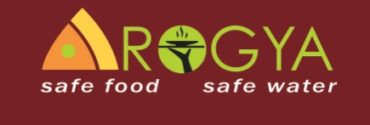



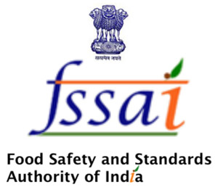

Certificate of Participation – Food Safety Training


Sustainable Hyderabad – Pilot Project Coordinator

Food Safety Trainer

Local vendors, trained to work as Food-Safety Trainers, conducted the training. The Training was organized by the joint cooperation of Dr. Reddy’s Foundation and the University of Goettingen/Sustainable Hyderabad Project, supported by Institute of Preventive Medicine, Dr. T. Neeraja of the Home Science College (ANGRAU) and other local Experts for Food Safety and Nutrition in Hyderabad.
We herewith certify, that___________________________________
has successfully participated _____ of four days in the
Food Safety Training
for Street Food Vendors in Hyderabad.

